Website Project Documentation

Project Title: Furever Care - Pet Care Website

Prepared by: Voeval, Okorie, Joseph, Covenant, David, Chioma

Course/Instructor: Responsive NextGen Website Development

Date: 13/09/2025

# Table of Contents

1. Introduction  
2. Project Objectives  
3. System Requirements  
4. Design Documentation  
5. Implementation  
6. Challenges and Solutions  
7. Testing  
8. Conclusion & Future Improvements  
9. References

# 1. Introduction

This project, “Furever Care”, is a responsive single-page application (SPA) designed to connect pet owners, veterinarians, and animal shelters.   
The purpose of the website is to simplify pet care by offering features such as booking veterinary appointments, adoption services, and pet care resources.  
The scope of this project includes a Pet Owner page, Veterinarian page, and Animal Shelter page.

# 2. Project Objectives

- Provide a platform for pet owners to book veterinary appointments easily.  
- Enable veterinarians to manage appointments.  
- Support animal shelters in listing pets available for adoption.  
- Educate pet owners on proper pet care practices.

# 3. System Requirements

Hardware Requirements:  
- Laptop/Desktop with at least 4GB RAM  
- Internet connection  
  
 Software Requirements:  
- Operating System: Windows  
- Browser: Chrome, Firefox, and Edge  
  
 Development Tools:  
- Frontend: HTML, CSS, JavaScript  
- Design Tool: Figma  
- Code Editor: VS Code

# 4. Design Documentation

-Site Map:  
 Home → Pet Owner Page → Veterinarian Page → Animal Shelter Page  
  
 -Wireframes/Mockups: 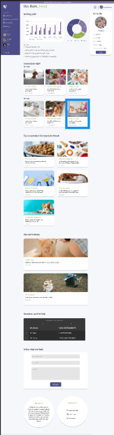 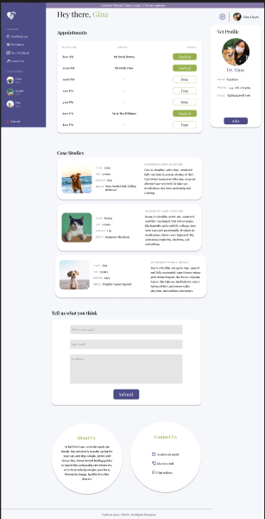 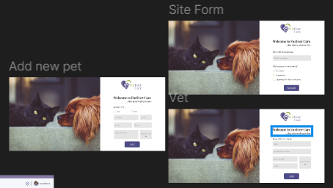 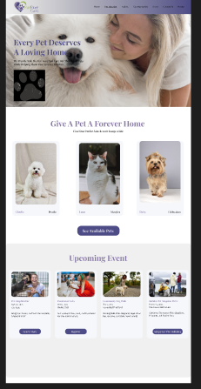  
  
 -Branding:  
 - Colors: Blue rgba(78, 76, 134, 1), White rgba(245, 247, 251, 1), Purple rgba(135, 120, 164, 1)  
 - Font: Playfair Display   
 - Logo: 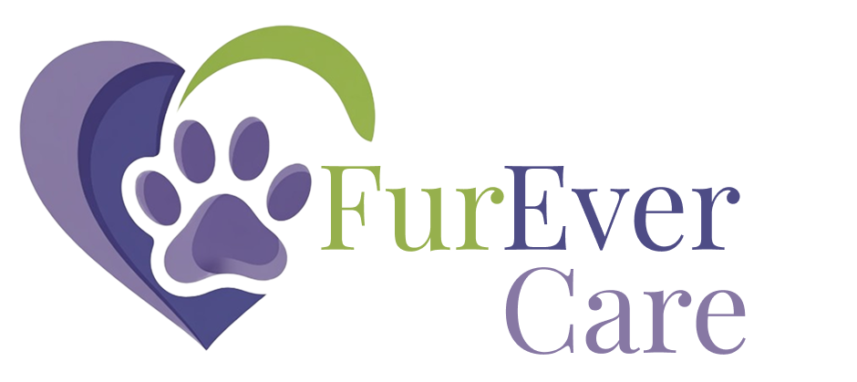

# 5. Implementation

Home Page: Provides an overview of the platform and navigation links.  
  
 Pet Owner Page: Allows users to register, manage profiles, and book vet appointments.  
  
 Veterinarian Page: Displays vet profiles and scheduled appointments.  
  
 Animal Shelter Page: Lists pets available for adoption with contact options.  
  
 Other Pages: Contact, About Us, FAQs.

# 6. Challenges and Solutions

-Challenge: Ensuring mobile responsiveness.  
 Solution: Used Tailwind CSS with flex and grid layouts.

-Challenge: Limited development time.  
 Solution: Prioritized core features first, added extras later.

# 7. Testing

Testing was carried out through:  
- Browser Testing: Checked on Chrome, Firefox, and Edge.  
- Responsiveness Testing: Used Chrome DevTools for mobile and tablet views.  
- User Testing: Collected feedback from sample users.  
  
 Results: Website is responsive, pages load correctly, and navigation is intuitive.

# 8. Conclusion & Future Improvements

The “Furever Care” website successfully provides a platform that connects pet owners, veterinarians, and shelters.   
Future improvements may include integrating an online payment system, live chat support, and AI-driven pet care recommendations.

# 9. References

- W3Schools (https://www.w3schools.com)  
- MDN Web Docs (https://developer.mozilla.org)  
- Tailwind CSS Documentation (https://tailwindcss.com)